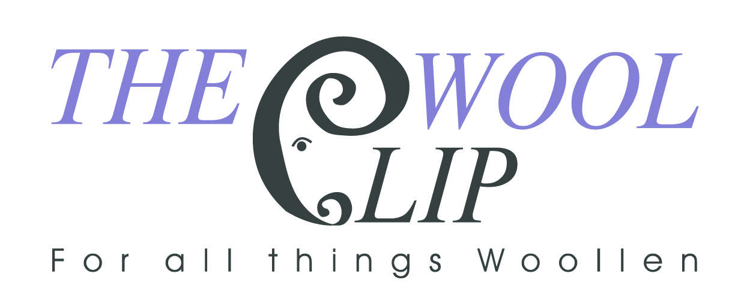
Woolclip, Priests Mill, Church Terrace, Caldbeck, Wigton CA7 8DR
016974 78707
shop@woolclip.com www.woolclip.com

Join The Wool Clip co-operative
  - Share your creativity, grow your practice and help champion British wool.
Thank you for your interest in joining The Wool Clip. Since 2001, our co-operative has brought together Cumbria-based makers who share a passion for British wool, sustainable natural fibres and beautifully made work.
Membership offers more than a place to sell. It is an opportunity to become part of a supportive creative community: sharing ideas, skills, suppliers and inspiration while helping to run a successful shop that none of us could operate alone.

What membership offers
- Your own space in our Caldbeck shop to display and sell your work.
- The support, knowledge and friendship of fellow wool workers.
- A shared retail presence, website, marketing and opportunities to take part in shows and events.
- Monthly sales information and payment directly into your nominated bank account.

Who we are looking for
We welcome applications from makers whose work uses predominantly British wool and brings something distinctive to the range already offered in the shop. To keep the collection varied and interesting, we consider how each applicant’s materials, techniques and products complement those of current members.

How the co-operative works
Every member has an equal voice in decisions and shares responsibility for the shop and the wider co-operative. Members normally work in the shop for at least three days each month and attend a monthly members’ meeting. Other responsibilities - including marketing, administration, upkeep, shows and events - are shared according to members’ skills and availability.
The shop is open from 11.00 am to 4.00 pm, Tuesday to Sunday, from mid-February until early January. It usually closes for five to six weeks during January and February for cleaning and maintenance. Parking is available at Priest’s Mill.

The co-operative currently retains 25% commission on shop sales. This contributes to rent, electricity, marketing, the website and other running costs.

Support for new members
You will receive full training and be paired with a member buddy who will support you during your first months, including working alongside you in the shop. New members begin with a six-month probationary period. At the end of that period, you and the existing members can decide whether full membership is the right next step.

How to apply
Please tell us about yourself and your work. We would love to learn about your materials, creative process, inspirations and the products you would like to sell.

Full name:

Email address:

Phone number:

Postal address:

Website or social media links:

About your work
Please describe your practice, process and inspirations, and explain how British wool features in your work.

Skills you could contribute
Please tell us about any other skills that could support the co-operative, such as marketing, social media, accounting, administration, retail, painting, DIY, events or digital skills.

Examples of your work
Please include a few clear images of the products you would like to sell. We will also ask shortlisted applicants to bring two or three examples to the shop so that members can review the quality, originality and fit of the work before offering a probationary place.

We would love to hear from you
Thank you for considering The Wool Clip. We appreciate the time and care involved in every application and will be in touch as soon as we can.

The Wool Clip members

