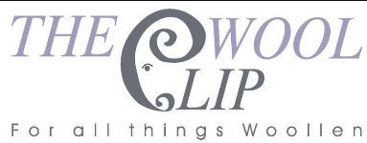
26 March 2026
Dear All
Just a few days until the clocks "spring" forward, the evenings get lighter and, let's hope, the days get warmer and drier too. We seem to have had a few hints of spring in recent weeks but then back to wind, rain and even a touch of snow on the fells above Caldbeck.
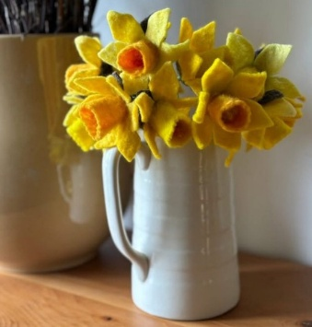 | 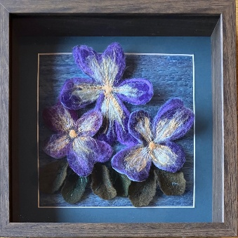 | 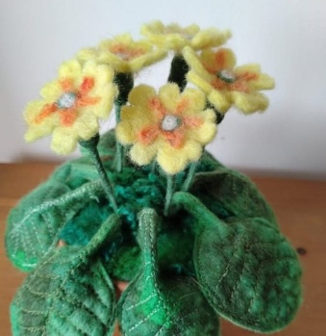
We've plenty of seasonal flowers and spring colours in the shop at the moment - as well as the landscape palette of our 25th anniversary items. The daffodils and primroses above have been felted by Linda and the framed picture was made by Jane. The embellished coat and the Easter bunny toy below are Marion's.
Caldbeck is full of real daffodils at the moment too and the village is a great place to visit if you want to avoid the Lake District crowds. There's a car park by the river (as well as the small one near Priest's Mill) and plenty of options for getting outdoors, exploring the river valley or the fells, and enjoying a nice lunch. As well as The Wool Clip, there are other lovely shops stocked with unique locally-made items, including Hesta Scene, the Caldbeck Crafters Co-operative and others dotted about. Well worth a visit.
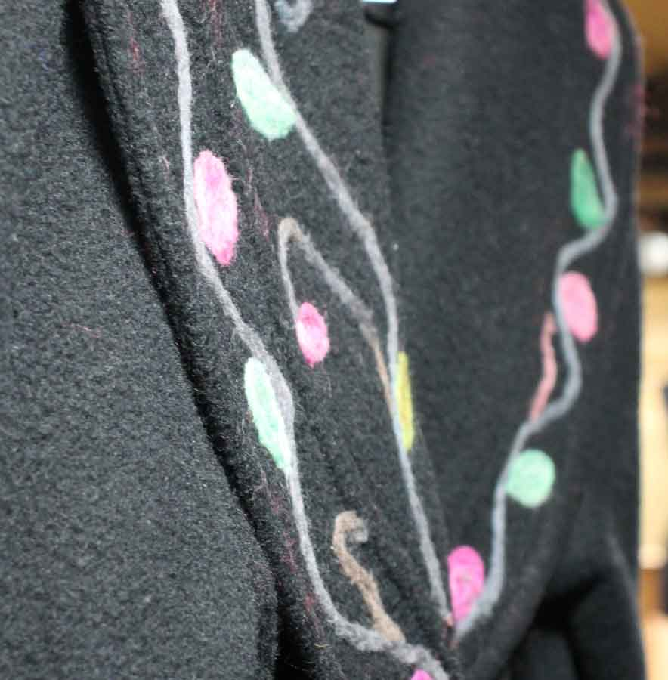 | 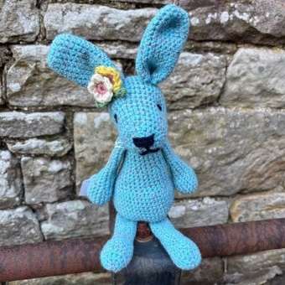 | 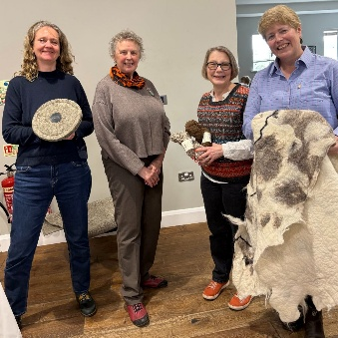
One piece of recent Wool Clip news is that Alice represented us at a meeting of the Cumbria-Westmorland Federation of Women's Institutes (CWFWI). The Federation recognises the need to support British wool, farmers and producers and is developing a more specific resolution on the topic. Various presentations promoted the value, variety of uses and benefits of wool, encouraging WI members to champion its use and get involved in the resolution process. The other speakers were Sally Phillips from Chimney Sheep and Wendy Dickinson, who is a fourth generation farmer with a flock of Rough Fell sheep. Sally, Wendy and Alice are shown above with Karen Hanks, Chair of CWFWI.
Looking ahead, our Caldbeck shop will be open on Easter Monday (a Bank Holiday) as well as our usual Tuesday to Sunday opening. Members of the co-operative will be in the shop from 11am to 4pm each day. Please pop in, have a chat and a browse and, we hope, find something you'd like to buy too. We are all about celebrating British wool and we're more than happy to talk about our history, our work and our plans for the rest of our 25th year.
Whatever you're up to over Easter, have a good one and we hope to see some of you in Caldbeck soon.
Best wishes,
The Wool Clip
PS If you're not heading to Cumbria, don't forget that we also have an online shop, stocked with our yarn and creations. There is also a 25th Anniversary page with some of the items we've designed and made to sell in aid of our Anniversary Awards.

