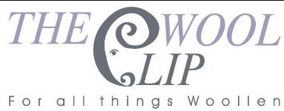
20 May 2026
Dear All
Thank you to everyone who has visited The Wool Clip in recent weeks - it's been busy and we love meeting other wool enthusiasts and sharing that commitment to wool. We've lots going on with a big local event in June, keeping the momentum going on some special 25th anniversary projects and welcoming a guest maker for the weeks ahead. Read on for more news ...
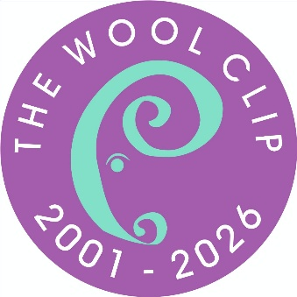 | 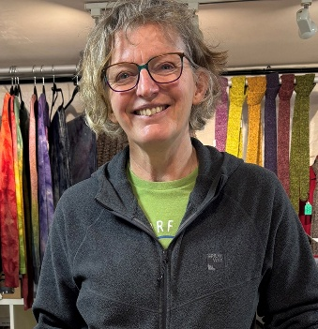 | 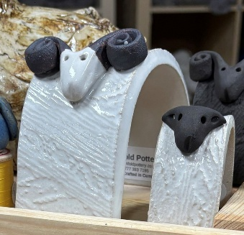
Just a month to go until the Cumbrian Wool Gathering at J36 of the M6 near Kendal. This is a brilliant event for wool enthusiasts and we'll be there with a Wool Clip stand at H5 - plenty of chance to say Hello, browse our work and chat about our 25th anniversary too. The event is held on Saturday 20th and Sunday 21st June and you can find full details on the event website as well as by following us on social media.
On our 25th Anniversary, things are moving apace. We're delighted to have received our first Anniversary Award entry already as well as attracting plenty of interest from other new businesses and more donations to the fund that's enabling these £250 bursaries. You can find out about the fundraising, our own special items for sale and how to apply for an Award on our website - just look for the 25 Years section.
Also for the 25th Anniversary, we're working on special pieces for our 25 Years in the Making exhibition at Farfield Mill near Sedbergh, opening in September. We're planning to announce the first Anniversary Awards winners then too. More information (and work in progress images) to follow on our Facebook and Instagram channels.
Back to the present, we're delighted to have a selection of Clare Farley's ceramic work in the shop. Clare, who trades as Pinfold Pottery, is a good friend of The Wool Clip and those of you who've popped into Basecamp North Lakes and seen Ruth and Linda's work may have spotted Clare's too. Inspired by gardens and by livestock, you'll spot a few sheep on Clare's display at Caldbeck.
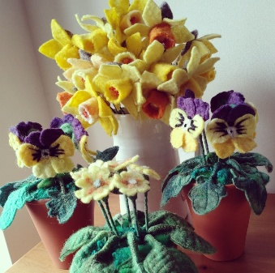 | 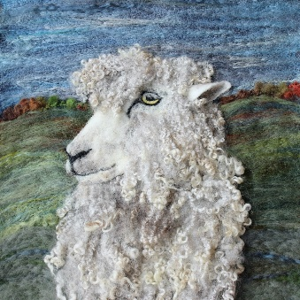 | 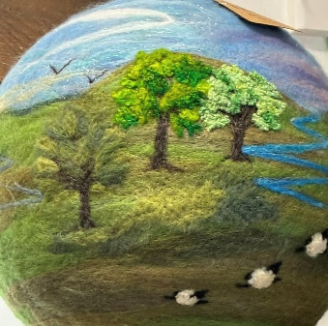
In amongst everything else, of course, we're all involved in ensuring that the shop is open and in creating new stock to sell.
Linda's flowers featured in a profile article in our local paper, Jane's native breed pictures always intrigue customers (this one is a Leicester Longwool sheep) and Susanna's work uses various techniques to create hangings, pictures, necklaces and some lovely padded boxes/pin cushions that make great gifts for other crafters.
If you haven't visited us for a while (or had a look in our online shop) then it's worth a visit as there's always something new to browse.
Best wishes,
The Wool Clip
PS Just a few days to go to the long weekend and Jane will be opening up the shop at Caldbeck for an extra day on Bank Holiday Monday (25th May). Opening hours are 11am to 4pm as usual on our regular Tuesday to Sunday opening.

