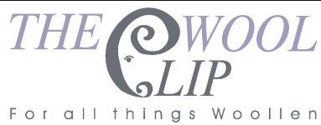
9th June 2026
Dear All
Thank you to everyone who has visited The Wool Clip shop recently. We've had high summer temperatures, brisk breezes and heavy rain showers, sometimes all on the same day! That's when wool comes into its own, of course, and when keeping an extra layer handy makes sense.
Read on for confirmation of our location at the Cumbrian Wool Gathering, an approaching entry deadline for the first tranche of our 25th Anniversary Awards and news of our 25th Anniversary exhibition at Farfield Mill.
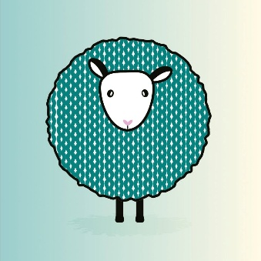 | 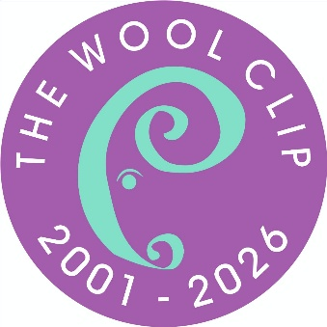 | 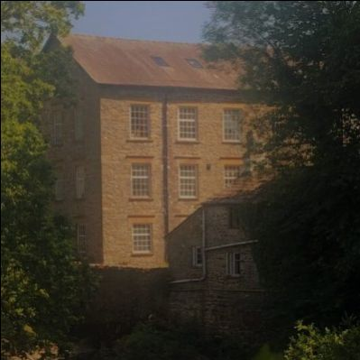
We're really looking forward to the Cumbrian Wool Gathering at Junction 36 Auction Mart on Saturday 20th and Sunday 21st June. We'll be on Stand H5 so please look out for us and have a browse as there'll be a selection of our wares for sale on the stall as well as information about different aspects of our 25th Anniversary. Petra, Marion and Ruth from The Wool Clip co-operative will be there at various times on Saturday 20th June and then Ruth will be doing a second day on Sunday 21st, this time with Alice and Paula. Please say "Hello".
If you're travelling to Cumbria for the event and would like to call in at The Wool Clip shop in Caldbeck as part of your trip, it'll be open over the weekend too, with Linda on Saturday 20th and Julia on the Sunday opening up from 11am to 4pm.
As part of our 25th Anniversary celebrations we're planning to make several Awards (each of £250) as bursaries to new or potential new wool-based businesses in Cumbria. Further details and the application form download link are on our website here.
The plan is to announce a first tranche of winners in early September and then a few more at the very end of the year. Fundraising for the Awards has gone well so far *** and we're keen to encourage more applications. It's a very simple process and the entry deadline for the first tranche is Monday 4th August (less than two months away now) so please spread the word to anyone you know who might be interested - we really want to support several new wool businesses if we possibly can in this anniversary year. Thank you.
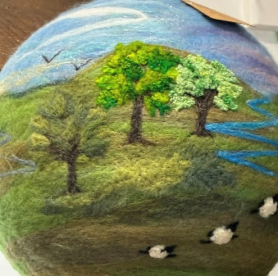 | 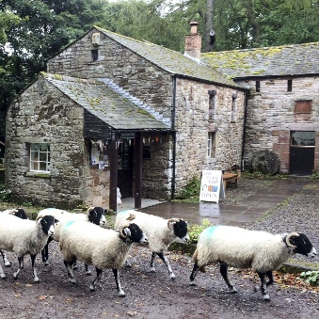 | 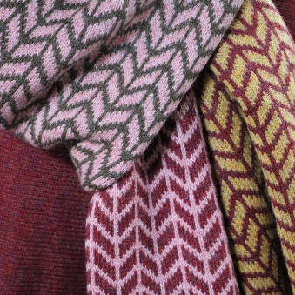
Finally, for now, we can confirm that our exhibition The Wool Clip - 25 Years in the Making, will be in the Loft Gallery at Farfield Mill (near Sedbergh) from Wednesday 2nd September through to Sunday 1 November. The focus will be new creative woollen pieces, specially designed to celebrate our Anniversary and each one made by a current member of the co-operative. If any of you remember our previous exhibitions at Rheged and UpFront, you'll know that this should be something a bit special.
There'll be other textile-related exhibitions elsewhere in the Mill that overlap with ours and Jan has a couple of weaving workshops in the same period too so please have a look at the Farfield Mill website under What's On and get a date for a visit into your diary.
Finally, just to mention the images above - the felted picture globe is made by Susanna and the machine knitted scarves are Julia's work. Hope that this email finds you well and enjoy your summer - we hope to meet some of you in the weeks ahead.
Best wishes,
The Wool Clip
*** We are also still seeking donations to the 25th Anniversary Awards fund - full details of how to support this and, indirectly, support new wool-based businesses are on our website here.

