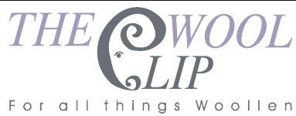
26th August 2026
Dear All
It's been a really busy few weeks with another busy one to come next week too. We're looking forward to celebrating our 25th year anniversary with our exhibition at Farfield Mill, which opens next Wednesday, and we're all finishing off our exhibition pieces, finalising plans and, of course, keeping the Caldbeck shop stocked and running too.
Thank you to everyone who has visited The Wool Clip shop through the summer - in sunshine and also in the cooler and wetter recent days. We hope you enjoyed your time in and around Caldbeck and thank you for making The Wool Clip part of your trip.
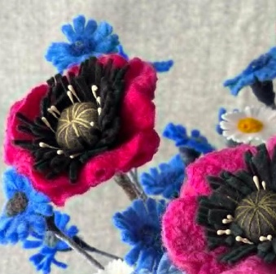 | 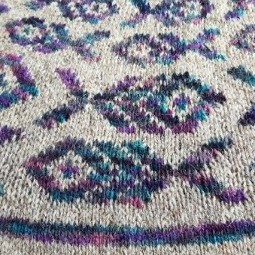 | 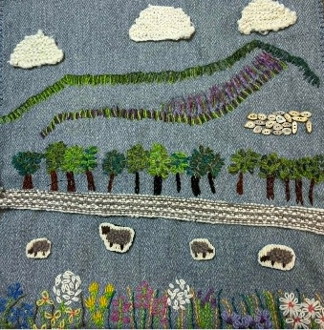
These rows of images show just glimpses of some of the work heading to Farfield Mill next week. Above you can see Linda's flowers, detail from Jean's sweater and one of Ruth's landscape hangings.
Below are a detail image from one of Julia's garments, work in progress from Chloe's Herdwick quilt and one of Debbie's eco-printed images.
We hope that many of you will be able to make it to Farfield Mill during The Wool Clip: 25 Years in the Making. It will be on display in the Loft Gallery from Wednesday 2nd September through to Sunday 1st November so there's plenty of time to plan a trip.
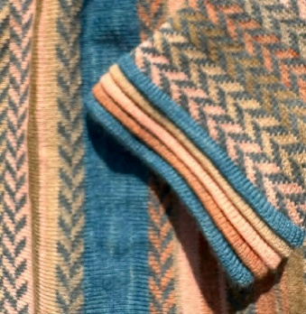 | 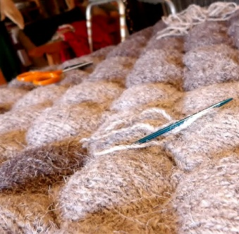 | 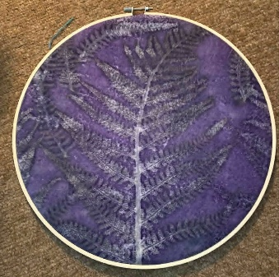
Unfortunately, setting up the exhibition and then being in time for the official "opening" means there are a few changes to our Caldbeck shop opening hours next week.
- We will be CLOSED on Tuesday 1st September.
- BUT we will be OPEN on the Monday Bank Holiday, 31st August.
- The only other change is that the shop will close at about 2pm on Wednesday 2nd to give us time to get down to near Sedbergh.
Apologies for any inconvenience that these changes may create for you but we hope that you understand.
Thanks and best wishes,
The Wool Clip
PS Our next e-newsletter will be with you early in September with news of our first 25th Anniversary Award winners, the latest on recruitment to The Wool Clip co-operative and photographs from the opening of our exhibition.

