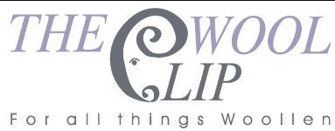
21st September 2026
Dear All
It's hard to believe that it's only three weeks since our previous e-newsletter - a lot has been happening for everyone involved in The Wool Clip co-operative. We wanted to share the headlines with links to longer news blogs on our website and also to show you glimpses of our exhibition at Farfield Mill, The Wool Clip - 25 Years in the Making.
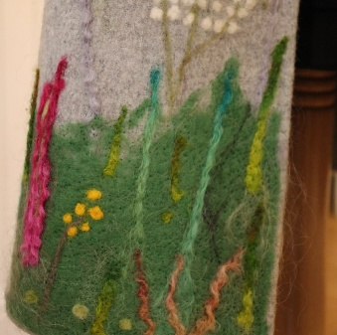 | 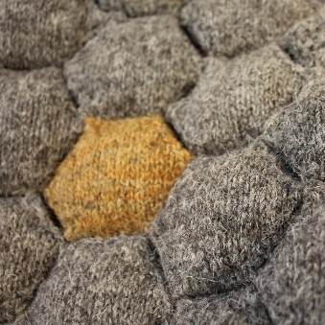 | 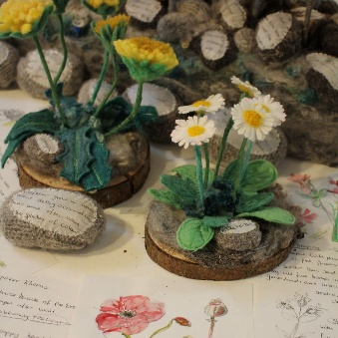
The fragments above are from Marion, Chloe and Linda's display pieces. Those below are from Jean, Julia and Ruth.
We've been thrilled by the initial response to our exhibition in the Loft Gallery at Farfield Mill. Thank you to all our friends and family who supported us in creating our pieces, displaying them as part of the exhibition and then celebrating the opening with us on 2nd September. It was lovely to welcome former members of The Wool Clip as well as six of our Anniversary Award winners (see below) and other friends of the co-operative. You can read a fuller report on our website here.
The Wool Clip - 25 Years in the Making is on display at Farfield Mill near Sedbergh until (and including) Sunday 1st November. It is open Wednesdays to Mondays, 10.30am to 4.00pm each day and there's plenty more to see at the Mill as well, lots of it textile related.
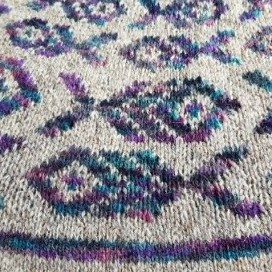 | 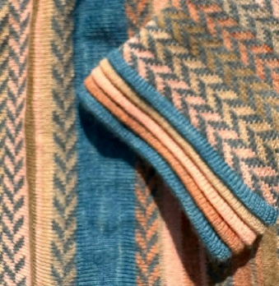 | 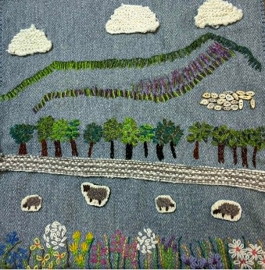
We took the opportunity of the exhibition opening to announce the first seven winners of our 25th Anniversary Awards. Each person has been given a small bursary of £250 to help them to develop their Cumbria-based and wool-based businesses. Their plans are all very different and it was really good to meet six of the seven winners at Farfield Mill to chat about their businesses and ideas.
You can read a fuller report and find out more about each winner here.
But that's not the end of the Awards. We're still inviting donations and fundraising ourselves to enable us to offer more Awards before the end of 2026. If the winners so far inspire you, please have a look at the blog and download the simple application form here. Then get in touch as soon as possible, The final, final deadline is Monday 30th November so that we can announce more winners in December.
All this and, of course, we're continuing to open up The Wool Clip shop at Caldbeck Tuesdays to Sundays throughout the Autumn. Please pop in and say Hello if you are visiting the Lake District and Cumbria. There's plenty to see and do around Caldbeck (at the Back o' Skiddaw) and some great refreshment stops in the village too.
Best wishes,
The Wool Clip
PS One final blog to mention. We're on the look out for new members to join The Wool Clip in the coming months. If that might be you (or someone you know) then the details are here and we'd love to hear from you.

